**Chapter 11 - The Metamorphosis**

**All Lectures Uploaded on YouTube:** [**https://tinyurl.com/fkm9-english**](https://tinyurl.com/fkm9-english)



# 

**Glossary:**

**Given below are the difficult words from the unit. Look at their meanings and use these words in your own sentences.**

| **Words** | **Meaning** |
| --- | --- |
| vermin | small animals or insects that are harmful and destructive, often used to refer to pests |
| armour-like | resembling or having the qualities of armor, which is protective clothing or covering |
| pitifully | in a manner that arouses pity or sympathy |
| strenuous | requiring a lot of effort or energy; physically demanding |
| fretsaw | a small saw with a fine blade used for intricate or delicate cutting |
| incomprehensible | impossible to understand or make sense of |
| discourtesy | rudeness or lack of politeness |
| concede | admit or acknowledge as true, often reluctantly |
| frenzy | a state of uncontrolled excitement or wild behavior |
| insistent | demanding something forcefully and persistently |

The following are the sentences for the above mentioned words:

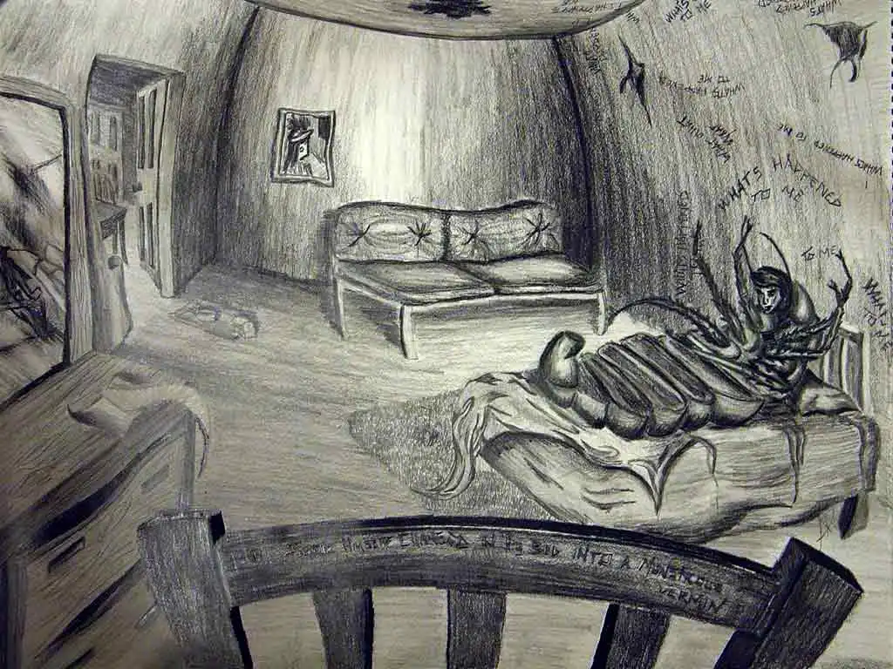

1. **Vermin**: The old factory building was infested with **vermin**, including rats and cockroaches, which posed a serious health risk.
2. **Armour-like**: The beetle's thick, dark shell provided an **armour-like** protection against predators.
3. **Pitifully**: The lost puppy whimpered **pitifully** by the side of the road until a kind person stopped to help it.
4. **Strenuous**: Climbing the steep mountain trail proved to be a **strenuous** task, demanding a lot of energy and stamina.
5. **Fretsaw**: He used a **fretsaw** to cut the delicate, curved patterns into the thin piece of wood for his model ship.
6. **Incomprehensible**: The professor's lecture on quantum physics was almost **incomprehensible** to the introductory students.
7. **Discourtesy**: Leaving without saying goodbye was considered a great **discourtesy** by the host.
8. **Concede**: After reviewing the evidence, the lawyer had to **concede** that the opposing argument had some merit.
9. **Frenzy**: The stock market fell into a **frenzy** as investors rushed to sell their shares after the unexpected news.
10. **Insistent**: She was **insistent** that they leave immediately, despite the others wanting to stay a little longer.

**Reading and Critical Thinking Skills**

**A. Reading Comprehension Questions:**

**Q1. What physical challenges does Gregor face as a result of his transformation?**

**Ans.** Gregor struggles with his new insect body. He finds it difficult to move, stand, or even get out of bed. His numerous legs are hard to control, and he can no longer perform simple tasks like opening doors. Over time, his body weakens due to neglect and injury.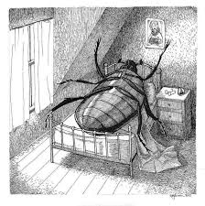

## Q2. Why does Gregor hesitate to open the door for the chief clerk?

**Ans.** Gregor hesitates because he realizes that his voice has changed, and he fears alarming the clerk and his family. Additionally, his transformation has made it physically difficult to open the door.

## Q3. How does Gregor justify his absence from work to the chief clerk?

**Ans.** Gregor tries to explain that he is feeling unwell but insists that he will still report to work soon. However, his speech is incomprehensible due to his transformation, making communication impossible.

## Q4. How do Gregor’s family members react to his transformation?

**Ans.** At first, Gregor’s family is shocked and horrified. His sister, Grete, initially takes care of him, but over time, she and the rest of the family grow resentful and see him as a burden. Eventually, they abandon him, leading to his death.

## Q5. What do you think the story might be trying to convey about the human condition or society?

**Ans.** The story explores themes of alienation, isolation, and the dehumanizing effects of societal expectations. Gregor’s transformation symbolizes how individuals can be

rejected by society and even their own families when they are no longer useful. It also reflects the struggle between personal identity and societal roles.

## Q6. What is the significance of the main character, Gregor Samsa, waking up transformed?

**Ans.** Gregor’s sudden transformation is symbolic of drastic, uncontrollable changes in life that lead to alienation. It represents how people can become outcasts due to illness, disability, or changes in their social status. His metamorphosis highlights the fragility of human relationships, especially when one's worth is tied to one's ability to work and provide for others.

## Words/Meanings

1. **Accusation**
   * **Deduced meaning:** Gregor feels a sense of guilt and indirect blame from his family for his condition. His family’s treatment makes him feel as if his transformation is his fault.
   * **Dictionary meaning:** A charge or claim that someone has done something wrong or illegal.

## Suppress

* + **Deduced meaning:** Gregor suppresses his desires and emotions, trying not to disturb his family despite his suffering. His family also suppresses their initial shock and, later, their sympathy toward him.
  + **Dictionary meaning:** To restrain, hold back, or put an end to something, often by force.

## Swag

* + **Deduced meaning:** In the context of the story, "swag" could be interpreted as the way Gregor struggles to move with his new insect body, awkwardly dragging himself around.
  + **Dictionary meaning:** A confident, stylish manner of carrying oneself; also refers to stolen goods or promotional merchandise.

## Abandon

* + **Deduced meaning:** Gregor is abandoned emotionally and physically by his family when they stop caring for him, leading to his ultimate demise.
  + **Dictionary meaning:** To leave someone or something behind, often permanently, without intent to return.

## Domed

* + **Deduced meaning:** Gregor’s new insect body may have a domed, rounded shape, making it harder for him to move and function normally.
  + **Dictionary meaning:** Having a rounded, convex shape like a dome.

## Nonsensical

* + **Deduced meaning:** Gregor’s speech becomes nonsensical to his family and others because, after his transformation, he can no longer communicate in human language.
  + **Dictionary meaning:** Having no meaning, being foolish or absurd.

**Grammar**

# Grammar Challenge: Contextual Language Use

"The sun shone brightly, and the birds were singing merrily. Sarah went to the park yesterday, but she did not have fun because the rain started pouring suddenly. It’s important for all students to study hard, and they will succeed in their exams."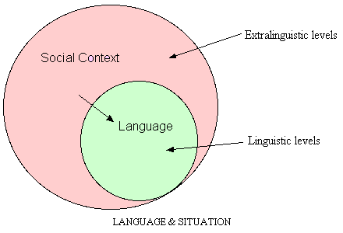

# Parts of Speech Exercise

**Identifying and labeling parts of speech:**

1. **She** (pronoun) **quickly** (adverb) **ran** (verb) **to** (preposition) **the** (article) **store**

(noun) **to** (infinitive marker) **buy** (verb) **some** (adjective) **groceries** (noun).

1. **The** (article) **big** (adjective) **brown** (adjective) **dog** (noun) **barked** (verb) **loudly**

(adverb) **in** (preposition) **the** (article) **yard** (noun).

1. **Although** (conjunction) **tired** (adjective), **Sarah** (proper noun) **continued** (verb)

**working** (verb) **diligently** (adverb).

1. **The** (article) **sun** (noun) **sets** (verb) **slowly** (adverb) **behind** (preposition) **the**

(article) **mountains** (noun).

1. **Wow!** (interjection) **What** (interrogative pronoun) **a** (article) **beautiful** (adjective)

**sunset** (noun).

# Tense Agreement Exercise

1. **She will go** to the beach tomorrow, and yesterday she **went** swimming.
2. **She will finish** her homework yesterday. *(Correction: She finished her homework yesterday.)*
3. **They have been studying** for this exam **for** three hours. *(Correction: They have been studying for this exam for three hours.)*
4. **She will go** to the beach tomorrow, and yesterday she **went** swimming.

## By the time he arrived, the party had already ended.

## **I am watching** a movie while he **reads** a book.

## **They had finished** their homework before dinner, and then they **played** outside.

1. **Next week, we will have completed** this project for two years.

*Read more about Tense Agreement here: (*[*https://www.kellogg.edu/upload/eng151text/chapter/text-verb-tenses-and-agreement/index.html*](https://www.kellogg.edu/upload/eng151text/chapter/text-verb-tenses-and-agreement/index.html)*)*

# Sentence Structure

1. **Sentence A:** The rain poured heavily. **Sentence B:** We stayed indoors.
   * **Combined Sentence:** We stayed indoors **as** the rain poured heavily.
2. **Sentence A:** Mary loves painting. **Sentence B:** She finds it relaxing.
   * **Combined Sentence:** Mary loves painting **because** she finds it relaxing.
3. **Sentence A:** She loves playing the piano. **Sentence B:** She practices every day.
   * **Combined Sentence:** She loves playing the piano, **so** she practices every day.
4. **Sentence A:** The movie was exciting. **Sentence B:** It kept us on the edge of our seats.
   * **Combined Sentence:** The movie was exciting, **and** it kept us on the edge of our seats.
5. **Sentence A:** John is a talented writer. **Sentence B:** His stories are captivating.
   * **Combined Sentence:** John is a talented writer **whose** stories are captivating.
6. **Sentence A:** My dog barks loudly. **Sentence B:** He gets excited when visitors arrive.
   * **Combined Sentence:** My dog barks loudly **because** he gets excited when visitors arrive.

# Vocabulary and Context Exercise

## Choose the appropriate word and explanation:

1. **The aggressive** dog chased the mailman away.   
   (Aggressive fits best because it describes a hostile or forceful nature.)
2. **The towering** mountain peak seemed to touch the sky.   
   (Towering means extremely tall.)
3. **The detective carefully examined the suspect** evidence to solve the case.  
   (Suspect means doubtful or questionable.)
4. **His speech was filled with heartfelt** and inspirational words that moved the audience.   
   (Heartfelt means sincere and deeply felt.)
5. **She gazed at the twinkling** stars in the night sky.   
   (Twinkling describes the bright and flickering light of stars.)
6. **The haunting** melody of the piano piece brought tears to her eyes.   
   (Haunting means deeply moving and unforgettable.)
7. **The chef added a pinch of salt** to enhance the flavor of the dish.   
   (Salt is the correct answer for seasoning.)
8. **The company’s rapid** growth over the past year has been impressive.   
   (Rapid means fast or quick.)
9. **The children’s jubilant** laughter echoed through the playground.   
   (Jubilant means joyful and happy.)
10. **His impulsive** decision to quit his job surprised everyone.   
    (Impulsive means acting without thinking.)
11. **The savory** aroma of freshly baked bread filled the kitchen.   
    (Savory means delicious and appetizing.)

